Inf3490

Mandatory Assignment 1

Marius Madsen

Mariumh

To run it. Simply type: python ob.py

Exhaustive search:  
observing the amount of time used when incrementing with one, you will notice that it takes time for n-1 cities smaller times n. this would mean n!

The best route with 10 cities is 7486.31 km long

With the tour Barcelona->Belgrade->Istanbul->Bucharest->Budapest->Berlin->Copenhagen->Hamburg->Brussels->Dublin->Barcelona  
the time used is approximately 3.24 seconds  
running for 24 cities would be 3.24\*24!/10!

Hillclimbing:  
Hillclimbing with ten cities gives the same best result but uses 0.04 seconds which is a speedup of 81 times

Example run of hillclimbing with statistics:

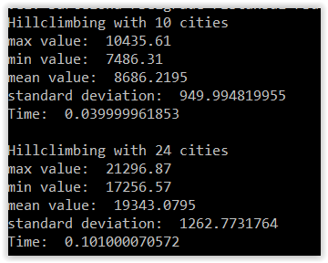

Genetic Algorithm:

I chose to use inversion mutation, where it chooses a random length of the permutation to inverse.

Also I chose Pmx since it’s a good crossover algorithm when working with permutations  
  
I chose populations 25 50 and 100  
the parameters are how many elites, how many mutant and crossover offsprings. Every parameter is supposed to be chosed as a percentage. If mutant+crossover >1 or is equal or less than zero it will result in a crash.  
having 0 offspring doesn’t make sense either also more than 1 would result in population increasing, which I assumed is not what we want  
for this instance I chose to have 10 percent elite and a quarter of each offspring

Ran with both 10 cities and 24 cities:

10 cities:

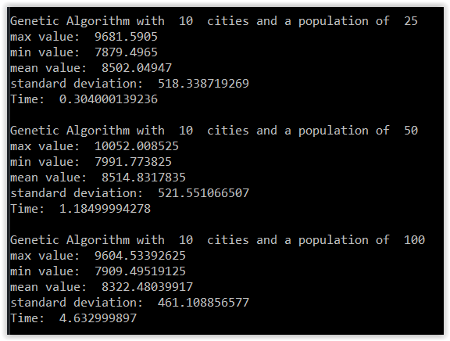

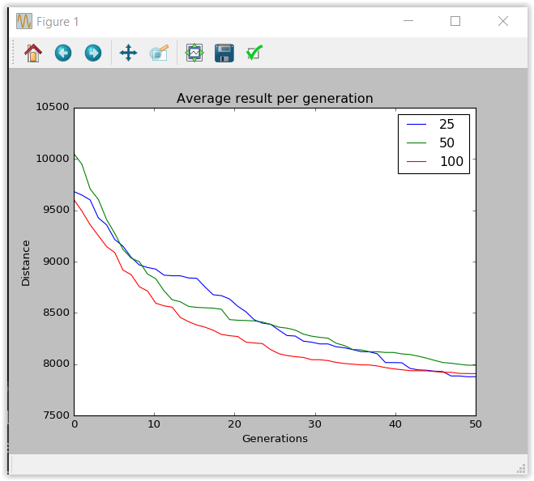

Cities = 24:

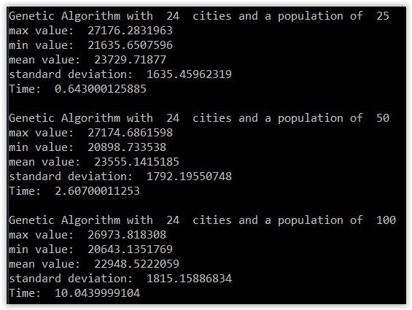

You can tell that for more generations it will get lower, but you can also see that its starting flatten out also, but looking at the sums, you’ll notice that they didn’t reach their global minimum

For the 10 first cities it almost reaches the shortest route, it has the possibility of reaching it

For 10 cities it is almost the same as exhaustive search (3-4 second)  
but for 24 cities, exhaustive search would never do it in 10 seconds

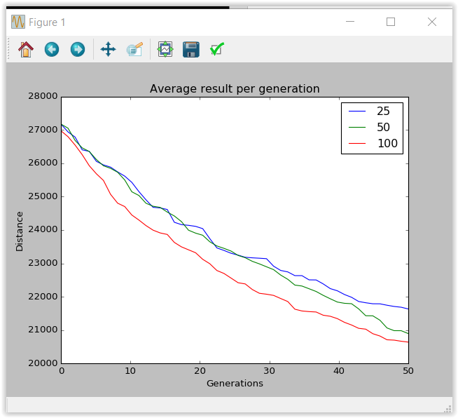

What I’ve done is that I I’ve made a populations with different permutations of the trip, then I have let x offspring be made by mutation and y offspring be made by crossover. To select which parent that is making a kid, I’ve chose to use rank selection. I also did that to choose parents to fill in next population. There is also a small group of elites made, that secures the best answer (about 10 percent of population)